Experiment 3

Title:
Navigation and Multiple Screens in the GrocerySpot App

Objective:
To understand screen navigation using buttons or gestures and implement multiple screens in the GrocerySpot mobile application.

Theory:
In the realm of mobile app development, creating an intuitive and seamless user experience is crucial. This experiment focuses on enhancing the user interface of the GrocerySpot app by introducing multiple screens and refining navigation through intuitive buttons or gestures. The objective is to improve user engagement and accessibility by organizing content efficiently and enabling smooth transitions between different sections of the app. By experimenting with various navigation patterns such as tab bars and side menus, we aim to tailor the user experience to individual preferences, ultimately providing a more personalized and efficient interaction with the GrocerySpot app.

Adding multiple screens to the application - GrocerySpot:
1)Welcome Page:
The welcome page of the GrocerySpot app features a visually appealing design with a welcoming message and brand logo also includes the GPS location. This page sets the tone for the user's shopping experience and provides a smooth entry point into the app.
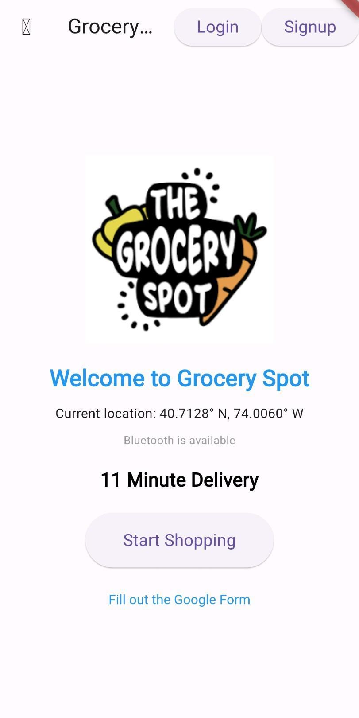
2)Filters Page:

The filters page of the GrocerySpot app is designed to showcase featured products, promotions, and categories. Users can easily apply filters selecting food preferences,location,price.
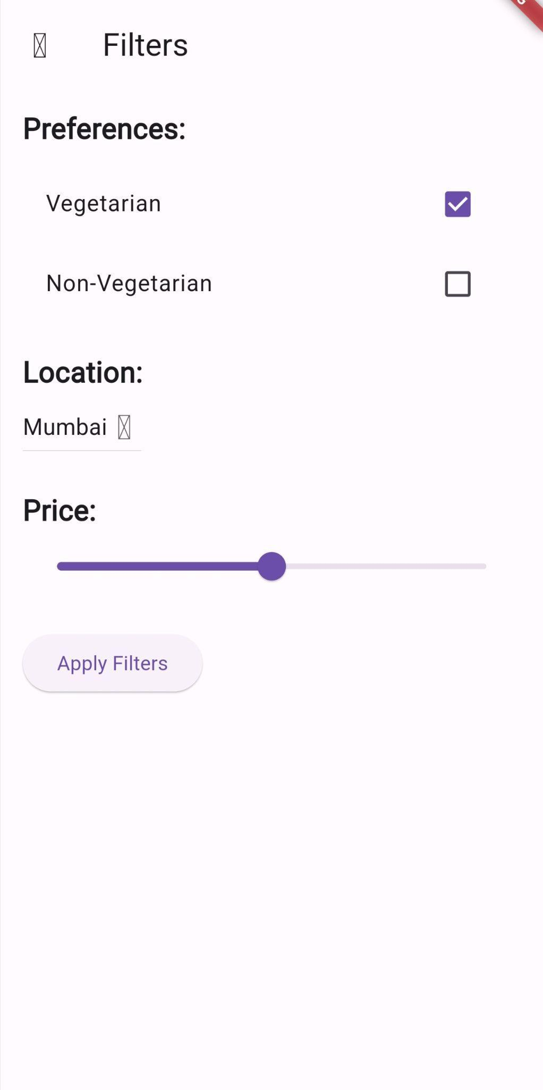

3)Product Listings Page:
The product listings page displays a grid or list of available products, allowing users to browse and search for items of interest. Each product is presented with an image, name, price, and add-to-cart button for easy shopping.
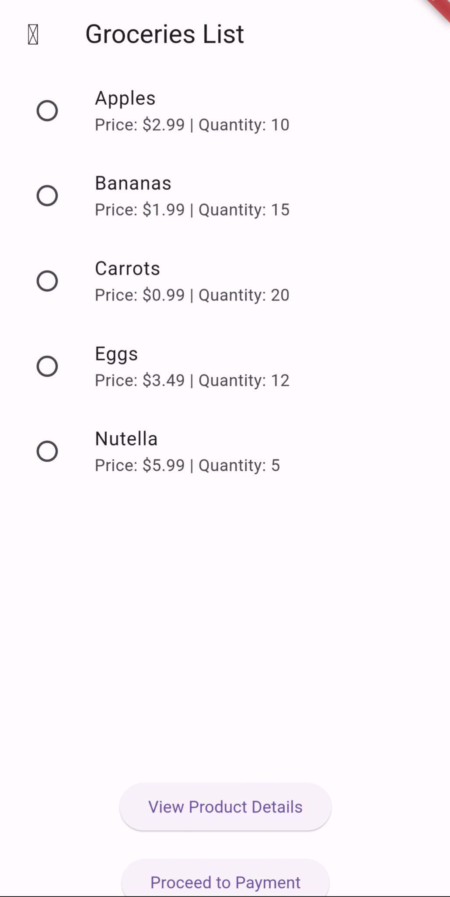

4)User Profile Page:
The user profile page allows users to manage their account settings, view order history, and track deliveries. It provides a personalized experience and enhances user engagement with the app.

5)Navigating between screens using buttons or gestures:
Accessibility: Providing multiple navigation options, whether through buttons or gestures, enhances accessibility and accommodates users with different interaction preferences.

Intuitiveness: Implementing gestures or buttons for navigation adds an intuitive layer to the app, making it easier for users to navigate through different sections and features.
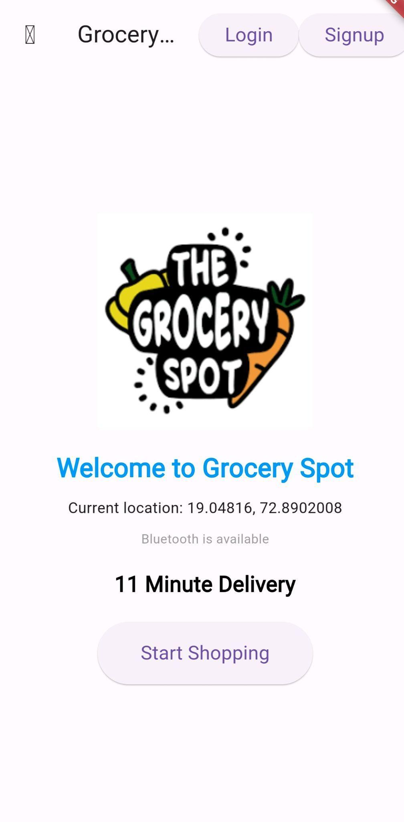 When Clicked on Start Shopping

When clicked on Apply Filters:
When clicked On View Product Details

Conclusion:
In conclusion, the implementation of multiple screens and navigation features in the GrocerySpot app has significantly improved the user experience and functionality. By incorporating seamless transitions between screens using buttons or gestures, users can navigate through the app more efficiently. The experiment explored various navigation patterns, such as tab bars, to provide users with a more customizable and intuitive interface. Overall, these enhancements have made the GrocerySpot app more accessible and engaging for users, leading to a more enjoyable shopping experience.

